Mountaindale
Retreat
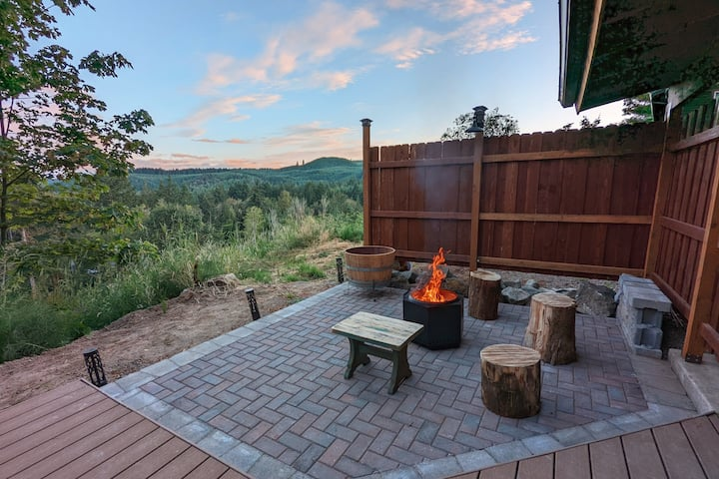

Things to do in our area…


FOOD:

- The Gaston Market – http://www.gastonmarket.com/
Address: 222 Front St, Gaston, OR 97119 | Phone: (503) 985-7038 | 35 miles
- One Horse Tavern – https://www.yelp.com/biz/the-one-horse-tavern-gaston
Address: 300 Front St, Gaston, OR 97119 | Phone: (503) 985-3273 | 25 miles
- Ace Tavern Restaurant & Bar – https://acetavern.com/
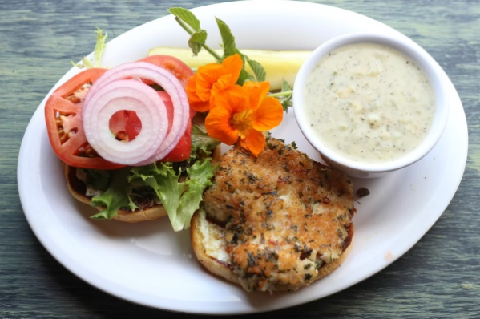
Address: 114 Front St, Gaston, OR 97119 | Phone: (503) 985-7900 | 25 miles
- Helvetia Tavern – https://therealhelvetiatavern.com/
Address: 10275 NW Helvetia Rd, Hillsboro, OR 97124 | Phone: (503) 647-5286 | 15 miles
- Roseanna’s Café – https://www.roseannascafe.com/
Address: 1490 Pacific Ave, Oceanside, OR 97134 | Phone: (503) 842-7351 | 68 miles (but worth it!)

WINE:

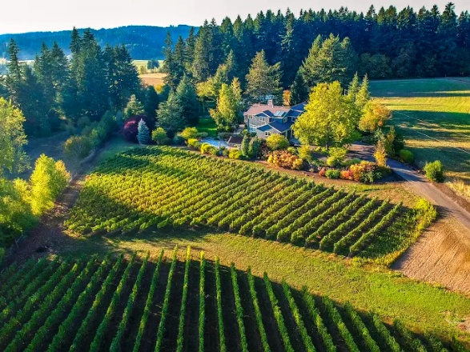
- Shumaker Vinyards – https://www.shumakervineyards.com/
Address: 13615 NW Mason Hill Rd, North Plains, OR 97133 | Phone: (503) 208-4544 | 13 miles
Established in 2014, the vineyard is dedicated to dry-farmed Pinot Noir and Pinot Gris, grown in unique soil types and tended by hand. The wines are described as accessible and intensely regional, with tasting notes often highlighting herbal, fruit, and savory complexities.
- Eagles Nest Reserve – https://eaglesnestreserve.com/
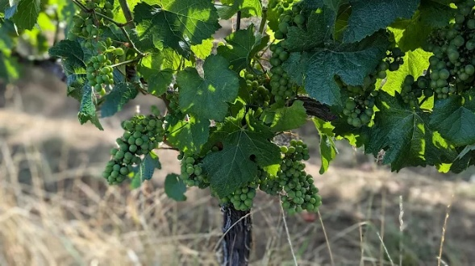
Address: 12995 NW Bishop Rd, Hillsboro, OR 97124 | Phone: (971) 487-1169 | 15 miles
Set amid the rolling hills of the Tualatin Hills American Viticultural Area (AVA). Stewardship of Place is paramount on this 160-acre estate which offers a diverse and beautiful landscape of vineyards, wetlands, fields of grazing alpacas and easement protected forest sanctuaries. These vineyards are sustainably managed on deep basalt and windblown loess soils without herbicides.

- Abby Creek Winery: The OG Crick – https://www.abbeycreekvineyard.com/
Address: 31441 NW Commercial St, North Plains, OR 97133 | Phone: (503) 0619 | 16 miles

This OG North Plains winery and tasting room are unlike anything else in Oregon. Hip-hop fills the space, wine is made on-site, and every detail reflects owner Bertony Faustin’s truth. “I didn’t start this in order to fit—I started this to stand out. This is my terroir,” Bertony says—"the foundation of everything here.”

- Helvetia Vinyards & Winery – https://helvetiawinery.com/
Address: 23269 NW Yungen Rd, Hillsboro, OR 97124 | Phone: (503) 647-7596 | 15 miles
A rustic, award-winning winery in the Tualatin Mountain foothills, known for its intimate, country atmosphere. It produces pinot noir, chardonnay, and pinot gris, with some grapes grown on its estate and others sourced from the Columbia Valley. Housed in a historic 1906 Sears Kit house, this winery offers tastings, tours, and outdoor seating with scenic vineyard views.
- Patton Valley: The Nomadic Winery – https://www.pattonvalley.com/
Patton Valley Wines, 2001 Main St, Forest Grove, OR 97116 | Phone: (503) 985-3445 | 18 miles
Provides private tasting & events. Reservations required.
- Sidereus Vineyard & Winery – https://www.pattonvalley.com/
Address: 5195 SW Hergert Rd Cornelius, OR 97113| Phone: (503) 992-1196 | 21 miles
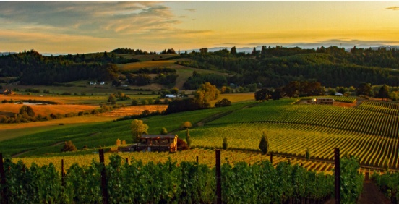
Provides great views & a brand new tasting room.
- Lenné Estate – https://www.lenneestate.com/
Address: 18760 NE Laughlin Road, Yamhill, OR 97148 | Phone: (503) 956-2256 | 33 miles
A boutique producer of premium pinot noir and Chardonnay located in the northern Willamette Valley near the town of Yamhill. Guided tours are available with reservation.
- Cana’s Feast Winery – https://canasfeast.com/
Address: 750 W Lincoln St, Carlton, OR 97111 | Phone: (503) 852-0002 | 36 miles
Cana's Feast is one of a kind. The owner fashions Italian varietals & a small bit of pinot. There is a whole selection of wonderful Italian wines to choose from, most of which are unavailable anywhere except at the vineyard. Cana’s also provides a covered outdoor patio & bacchii court.
- Stoller Family Estate – https://www.stollerfamilyestate.com/
Address: 16161 NE McDougall Rd, Dayton, OR 97114 | Phone: (503) 864-3404 | 43 miles
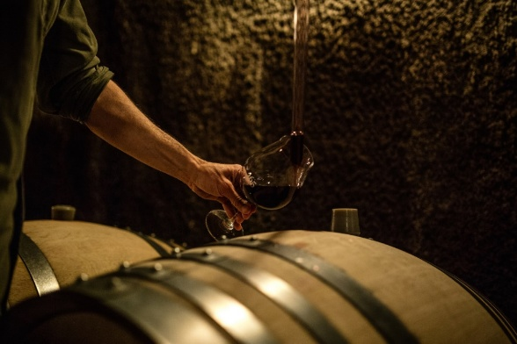
Provides a wine shop & tasting facility.
- Archery Summit Winery – https://www.archerysummit.com/
Address: 18599 NE Archery Summit Road, Dayton, OR 97114 | Phone: (503) 714-2030 | 43 miles
Provides a cave tour, Indoor Cave & Outdoor Terrace wine tasting facilities. Reservations required.

- Domaine Drouhin Winery – https://domainedrouhin.com/
Address: 6750 NE Breyman Orchards Rd, Dayton, OR 97114 | Phone: (503) 864-2700 | 44 miles
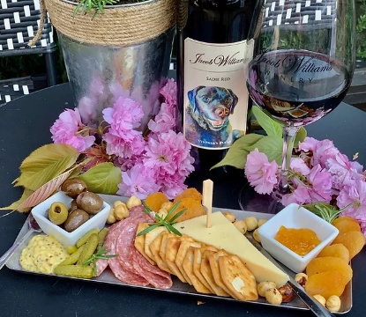
Provides a wine shop & tasting facility.
- Jacob Williams Winery – http://www.jacobwilliamswinery.com/
Address: 232 3rd St, McMinnville, OR 97128 | Phone: (503) 376-6601 | 45 miles
Jacob Williams offers an exciting array of boards, plates & a la carte items. All products are sourced locally. They also have a selection of signature, homemade products for your enjoyment.
- Árdíri Winery & Vineyards – http://ardiriwine.com/
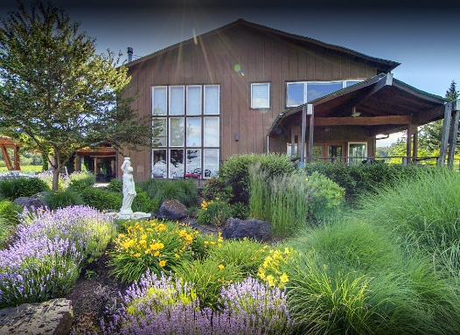
Address: 35040 SW Unger Rd, Cornelius, OR 37113 | Phone: 503) 421-2279 | 22 miles
Árdíri’s veranda overlooks captivating mountain views & acres of vines bearing the finest grapes in the region. Guests can nestle up to the fire while sipping their favorite wine, catch up with friends over a picnic lunch or saunter through the vineyard to soak up the romantic feeling of wine country.
- David Hill Winery – https://www.davidhillwinery.com/
Address: 46350 NW David Hill Rd, Forest Grove, OR 97116 | Phone: (503) 992-8545 | 20 miles
Provides tastings, events & education by appointment. To-go bottles available without reservation.
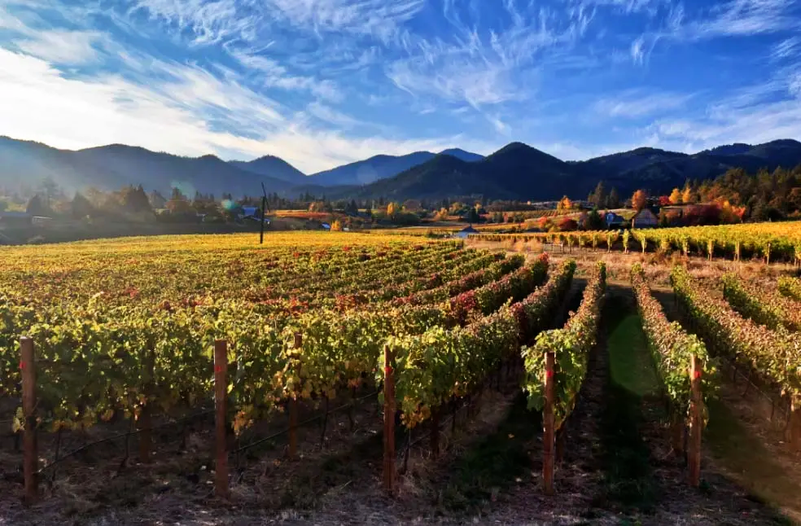
These are just a few of the world-class wineries available for tours and wine tasting in our area. Enjoy!

GOLF:

- Pumpkin Ridge Golf Club – https://www.pumpkinridge.com/
Address: 12930 NW Old Pumpkin Ridge Rd, North Plains, OR 97133 | Phone: (503) 647-4747 | 9.7 miles
Golf club in Washington County, OR, established in 1992. 36 holes.
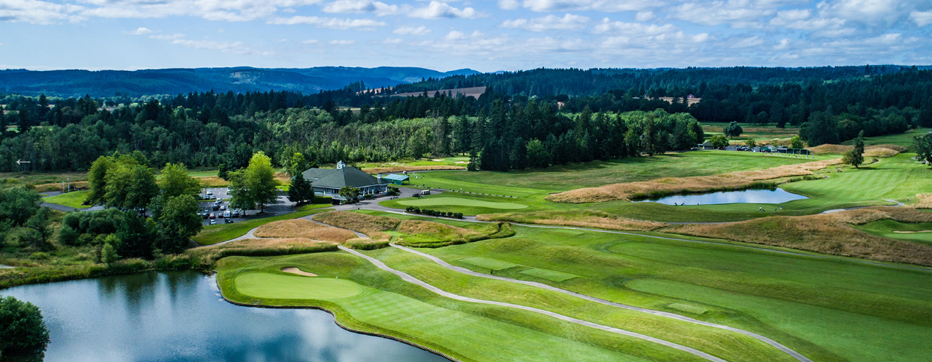
- Forest Hills Golf Course – https://golfforesthills.com/
Address: 36260 SW Tongue Ln #6242, Cornelius, OR 97113 | Phone: (503) 357-3347 | 19 miles
A timeless classic since 1927, offering 18-holes of beautiful golf surrounded by the foothills on the edge of wine country. They offer homemade pizza and ice cream along with other food & drink options.
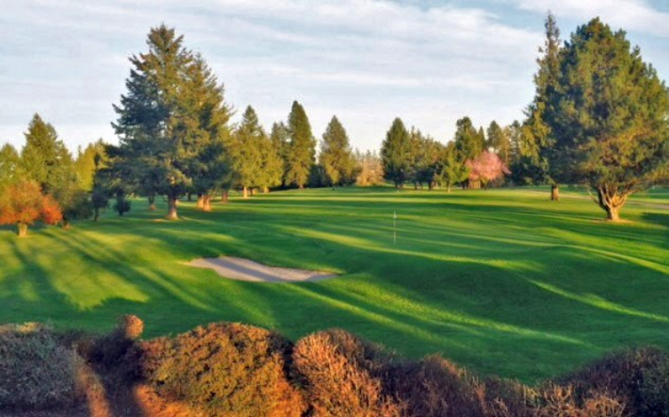
- McKay Creek Golf Course & Driving Range – https://www.mckaycreekgolf.com/
Address: 1416 NW Jackson St, Hillsboro, OR 97124 | Phone: (503) 693-7612 | 16 miles
Golf course in Hillsboro, OR. 9 holes of affordable golf on the west side of Portland.
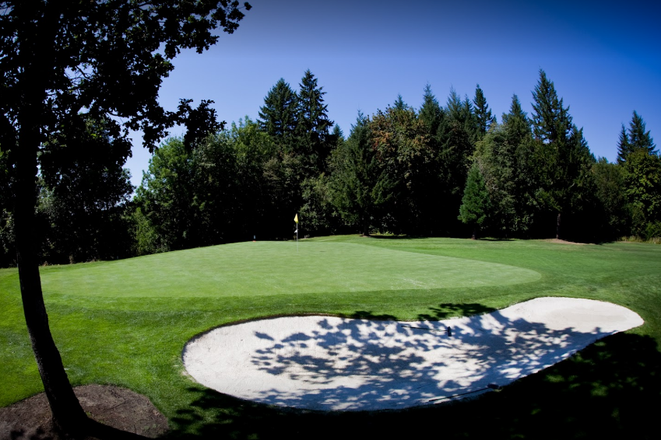
- Horning’s Hideout – https://www.horningshideout.com/
Address: 21277 NW Brunswick Canyon Rd, North Plains, OR 97133 | Phone: (503) 647-2920 | 9 miles
Offers disc golf, picnic area and great views.
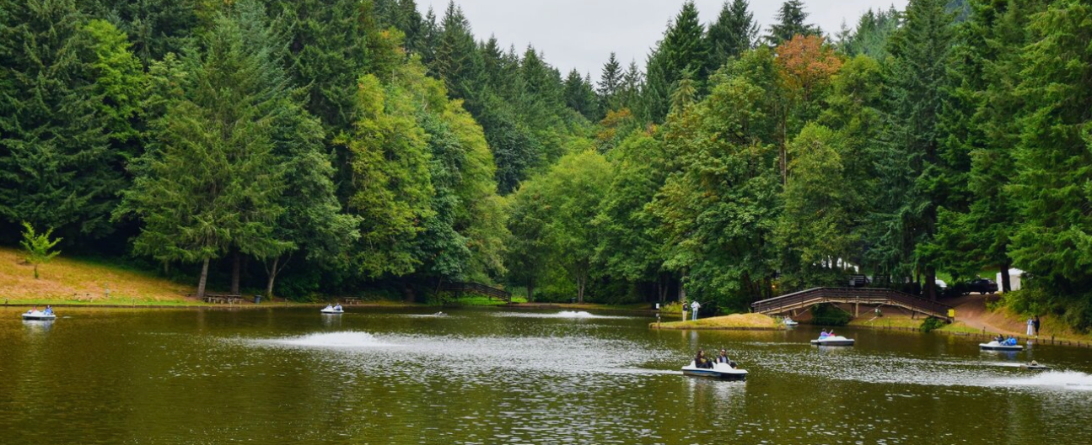

- Killarney West Golf Course – https://www.killarneywestgc.com/
Address: 1275 NW 334th Ave, Hillsboro, OR 97124 | Phone: (503) 648-7634 | 17 miles
Killarney West is a family-owned golf course built in 1981. This 9-hole, par 36 course is located in Hillsboro, Oregon off of Tualatin Valley Highway.
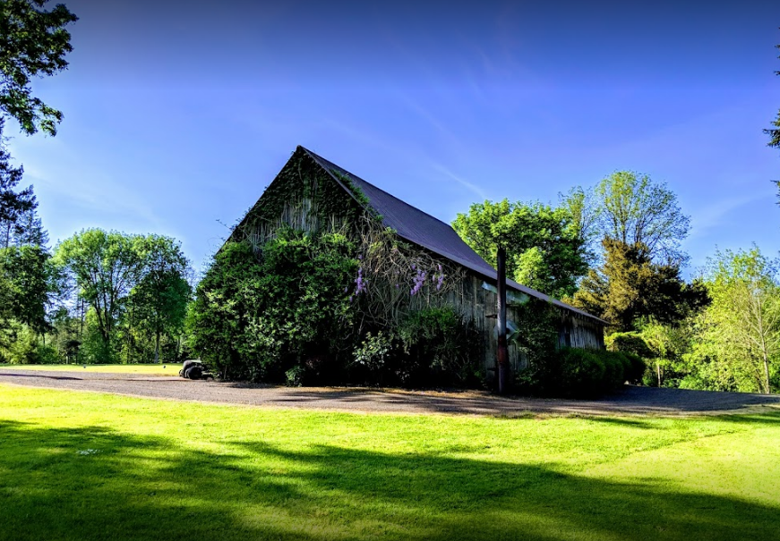
- Meriwether National Golf Club – https://meriwethergolf.com/
Address: 5200 SW Rood Bridge Rd, Hillsboro, OR 97123 | Phone: (503) 648-4143 | 20 miles
Meriwether National Golf Club is a 27-hole golf club in Washington County, just south of Hillsboro, Oregon. Opened in 1961, it has 3 regulation-length 9-hole courses and an executive-length course located along the Tualatin River in suburban Portland, Oregon.
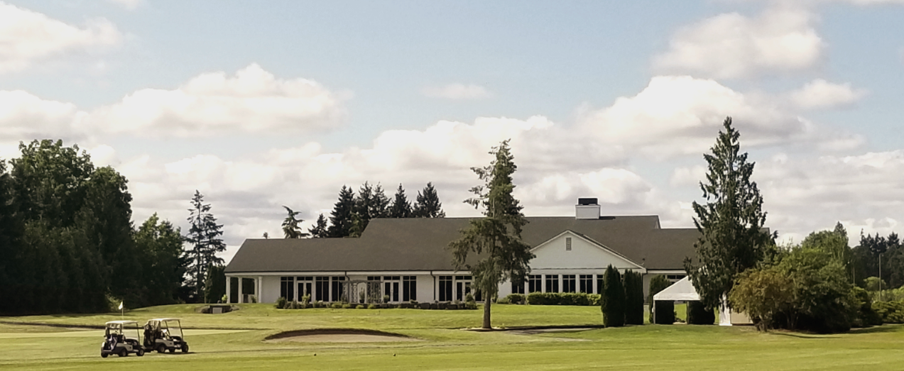

- Quail Valley Golf Club – https://www.quailvalleygolf.com/
Address: 12565 NW Aerts Rd, Banks, OR 97106 | Phone: (503) 324-4444 | 10 miles
Surrounded by picturesque foothills, Quail Valley is an 18-hole championship facility open to the public. Opened in 1994, this beautifully conditioned, links-style course is player friendly while offering a challenge to any golfer.
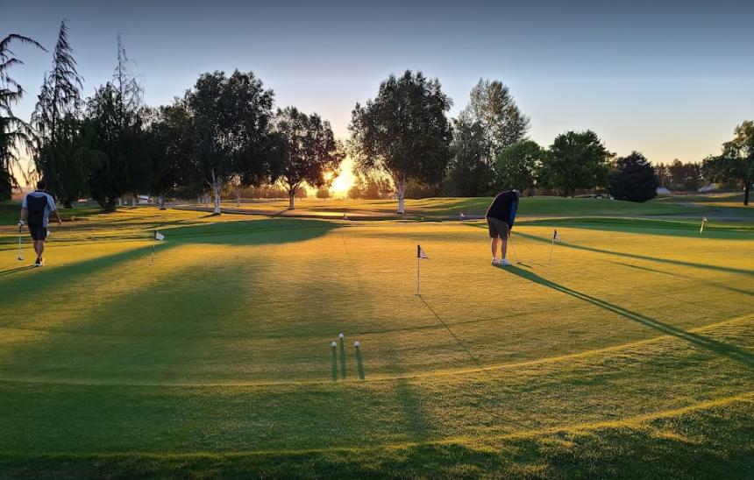

GOLF:

- Durant Olive Mill – https://durantoregon.com/durant-olive-mill/
Address: 5510 NE Breyman Orchards Rd, Dayton, OR 97114 | Phone: (503) 864-2000 | 43 miles
Offers an estate educational experience, official blue glass tasting with guided tour, olive oil & vinegar tasting bar. Reservations required.
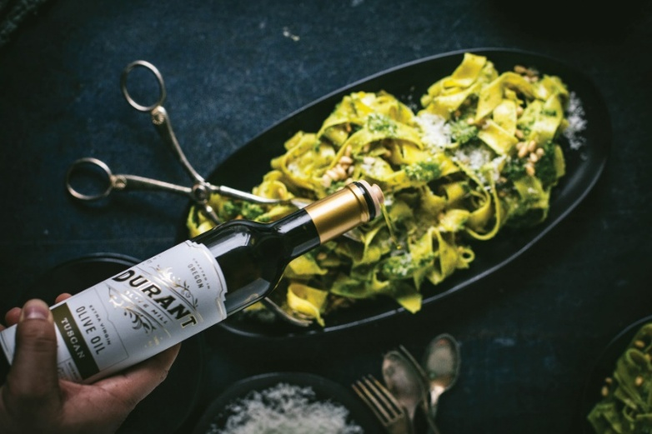
ADDITIONAL GUIDE TO ALL THINGS LOCAL

Visitor Resources for Portland, Oregon – https://medesign.org/portland/
Includes sections on the history of Oregon, things to do in Portland Metro (including garden guides), things to do on the Oregon Coast & things to do at the mountains.

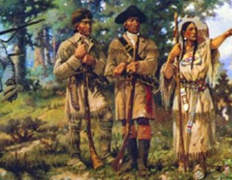
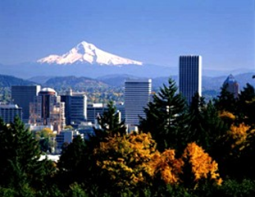

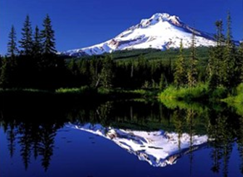


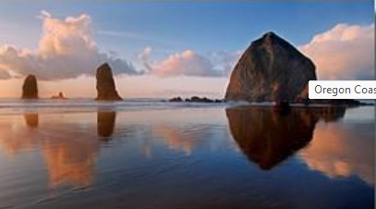

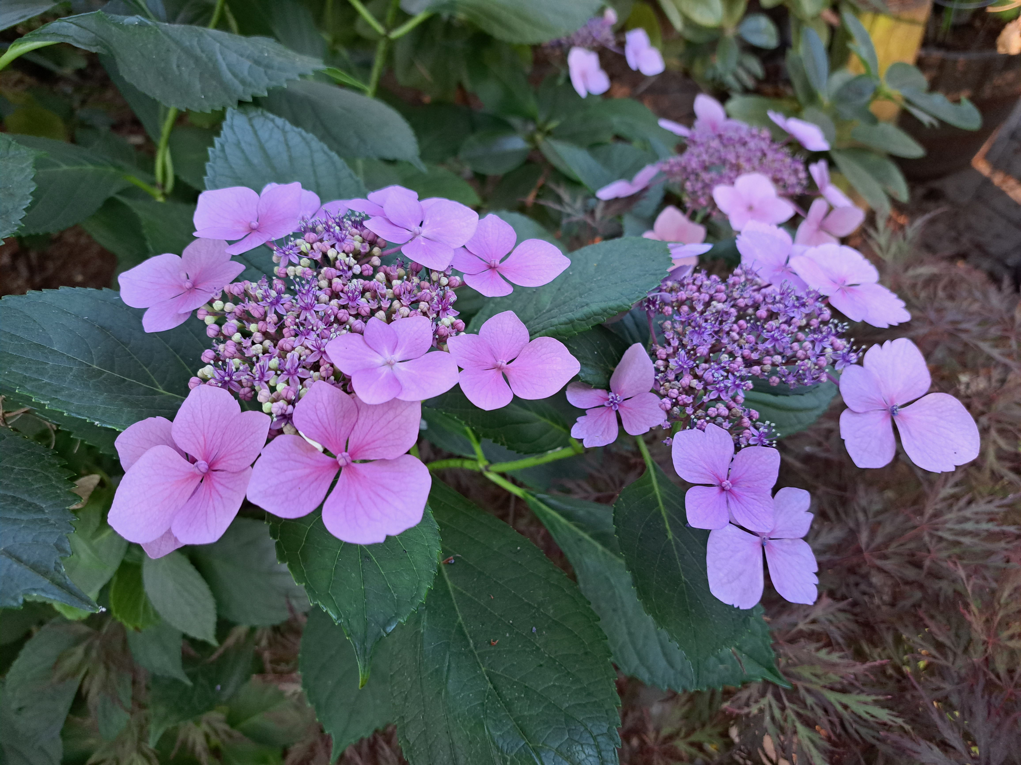

Thank you for choosing us – we hope you had a relaxing and comfortable stay.

The Murisons

Add things you have found interesting & useful in our area…

